# D:\Users\User\Documents\Anna\Documents\My Documents\Jurmalas_logo\Jurmala_logo-01.jpges_dzivoju_pie_juras_lielunesco_logo_lv_sadarbibaar

# 

# XV INTERNATIONAL VISUAL ART COMPETITION

# “I LIVE BY THE SEA”

# R E G U L A T I O N S

Jurmala Art School is organizing the **15th International Visual art competition “I live by the Sea”.** The theme of the competition varies every year and is connected with the sea.

To our mind Jurmala is a charming resort city, situated on the coast of the Baltic Sea. There is a 33 km long white sand beach, that doesn’t exist anywhere else in the world. We love our city and we are proud of it.

We consider Latvia as the land of the sea, which is given with 596 km long coastline. All children and young people from all the seas and oceans from all over the world are invited to participate in the competition.

|  |  |
| --- | --- |
| **ORGANIZER:** | **ART SCHOOL OF JURMALA (JŪRMALAS MĀKSLAS SKOLA)** |
| **VENUE:** | **Strēlnieku pr.30,, Jūrmala, LV – 2015, LATVIA** |
| **APPLICATION PERIOD:** | **January 29, 2016** |
| Address: | ART SCHOOL OF JURMALA,  Strēlnieku pr.30,  Jūrmala, LV – 2015,  LATVIA. |
| Sending by post: | Works have to arrive till January 29, 2016,  Strēlnieku pr.30, Jūrmala, LV – 2015, LATVIA |
| **THE THEME OF THE COMPETITION:** | **THE STORY IN THE SEASTONE** |
|  | **Have a walk to the sea and take a deep breath fresh air of the sea.  Stone reveals its long tour in the ancient world and the spacious sea. Stones are small and colourful, huge as sculptures, black made out of lava. Sea sides are so different.**  **What is THE STORY OF YOUR SEASTONE?**  **• Stones in a seaside architecture**  **• Fossils - witnesses of history**  **• Stone reflection in water**  **• Stone from the depth of the sea**  **• Stony seashore, etc.** |

|  |  |
| --- | --- |
| **The aims of the competition:** | * To actualize understanding in the ecology, diversity and richness of the sea; * To animateinterest and love of the place we come from ; * To highlight uniqueness of birthplace, the diversity of national culture and its beauty; |
| **The tasks of the competition:** | • To encourage children and young people to motivate  creative self-expression in Visual Art;  • To involve children and young people in getting acquainted with the environment and identify their national culture and  tradition wealth;  • To promote cooperation between the twin cities of Jurmala,  global contestants and their Member States, get to know  their culture, traditions and people;   * To create an opportunity for experience exchange among   children, youth and teachers, to make new friends, find new  cooperation partners and create new ideas. |
| **Organizers of the competition:** | **Art School of Jurmala** and **The City Council of Jurmala** |
| **Supporters of the competition:** | **The City Council of Jurmala** and **Līvu Akvaparks** |
| **The participants:** | - Children and Youth in age from 4 to 25.  - Works can be submitted by educational institutions, public organizations and individuals. |
| **Author of the work:** | An individual |
| **Work format:** | **-** Only originals will be accepted;  - Participants shall submit two-dimensional works;  - Work format - A3 format (30 × 42 cm) or  A2 format (42 × 60 cm);  - Work copies (Xerox, electronic etc.) won’t be evaluated;  - Computer graphic have to be printed in A4, A3 or A2 format paper; |
| **Work units:** | **-** An individual may submit **a maximum of 2 works.**  - Public organization may submit **no more than 4 works from**  **each age category and technique category.**  - Educational institutions one class may submit **no more than**  **four works from each age category and technique category.** |
| **Evaluation category:** |  |
| Age category: | 4-7 year old  8-11 year old  12-15 year old  16-25 year old |
| Technique category: | Painting  Graphics  Computer graphics  Silk painting – (presentation thin, light)  Batik - (presentation thin, light ) |
| In addition: | - Computer graphics works are judged without age categories.  - Children and youth works with special needs are judged in the separate category. |
| **Evaluation criteria:** | **- In the competition only individual works will be evaluated;**  - Work adequacy to the competition theme;  - The author's creative idea; |
| **Jury:** | - Jury is approved by the organizers of the competition.  - All works will be evaluated by an international jury, which consist of professional artists.  - In addition to the international jury, works may be evaluated by other Latvian organizations, as well as children's jury can be set up.  - Each technique category and age category are awarded with gold, silver and bronze medals.  - Jury will award with incentive prizes, acknowledgments and diplomas for successful themes revelation and artistic performances.  - The jury has the right to define the competition Grand Prix, award with the audience prize as well as grant with other prizes.  - The jury reserves the right:  - change the prize distribution by category;  - not evaluate the work of the competition, which does not comply with the regulations of competition;  - not to award any of the medal;  - award a number of first, second or third place;  - award with special prizes for a special performance; |
| **Submission of works:**  Submit to address:  By post: | January 29, 2016  Strēlnieku pr.30, Jūrmala, LV – 2015, LATVIA  Must be delivered till January 29, 2016 |
| Organization must submit : | PARTICIPANTS OVERALL LISTS in electronic and print -  **FILLED IN LATIN CAPITAL LETTERS:**  **Electronic** list filled in WORD format sending to [ilivebythesea@edu.jurmala.lv](mailto:ilivebythesea@edu.jurmala.lv);  **Printed** list added to work package; |
| List form available: | **ANNEX Nr.1**  [www.jurmalas.makslasskola.lv](http://www.jurmalas.makslasskola.lv) COMPETITION |
|  |  |

**Work labeling:**

|  |  |
| --- | --- |
| **INFORMATION CARD NR. 1**  has to be labelled on **REAR OF THE WORK** | **INFORMATION CARD NR. 2** has to be labelled below **the right bottom side of the work** (to be presented at the exhibition) |

BACK FRONT

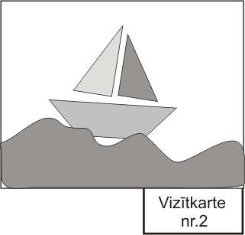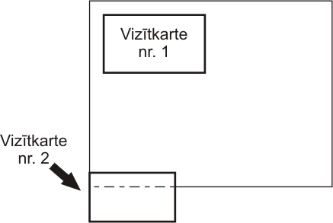

**INFORMATION CARD NR. 2** has to be glued and folded behind the work to make the evaluation anonymously.

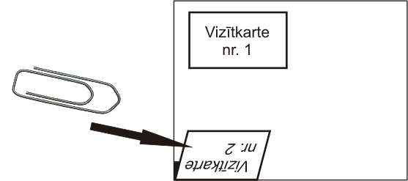BACK

Information cards available: **ANNEX Nr.2**

[www.jurmalas.makslasskola.lv](http://www.jurmalas.makslasskola.lv) COMPETITON

|  |  |  |
| --- | --- | --- |
| **Winner awarding:** | **March 11, 2016 at 13.00**  The awarding of the winners and opening of the exhibition, from the best works of the competition.  AT **LĪVU AKVAPARKS**  (Viestura iela 24, Jūrmala, LV-2010, LATVIA).  Exhibition will take place till April 10, 2016. | |
| **Organizers rights:** | * In the event participants can be photographed or filmed, photos, and audio-visual material can be published for non-commercial purposes. * Organizers may keep best visual art works for international traveling exhibition, or for different type of presentation needs, referring to the author. * Organizer becomes the owner of the works which was submited to the competition. Your application means that you agree with these terms and conditions. The organizer reserves the right to publish and exhibit work. * The organizer does not guarantee a return of submitted works after competition, and the work won’t be sent back by post. | |
| **Receiving works:** | * You will be able to receive the works at Art school of Jurmala during the month following the closing of the exhibition from May 2, 2016 to June 6, 2016 specify the time by telephone. +371 67767529 * After the exhibition organizers do not guarantee job storage. | |
| **OUR ADRESS:**  Art School of Jurmala,  Strelnieku prospekts 30,  Jurmala, LV-2015  T: +371 67767529, Fax: +371 67769257  Web: www.jurmala.makslasskola.lv | | **COOARDINATOR OF THE COMPETITION:**  Anna Vanaga  E-mail: **ilivebythesea@edu.jurmala.lv**  T: +371 67767529 |
| **The headmistress of Art school of Jurmala: T.Vaišļa**  **We wish you good luck! Thank you for your cooperation!** | | |

|  |  |  |
| --- | --- | --- |
| **ANNEX Nr.1** | **PARTICIPIANTS OVERALL LIST** | **XV INTERNATIONAL**  **VISUAL ART CONTEST**  **“I LIVE BY THE SEA”** |

**FILL IN BLOCK CAPITALS LATIN!**

**ORGANIZATION: \_\_\_\_\_\_\_\_\_\_\_\_\_\_\_\_\_\_\_\_\_\_\_\_\_\_\_\_\_\_\_\_\_\_\_\_\_\_\_\_**

|  |  |  |  |  |  |  |  |  |
| --- | --- | --- | --- | --- | --- | --- | --- | --- |
| NR. | COUNTRY | ADDRESS | AUTHOR  NAME, SURNAME | AGE | TITLE | TEACHERS  NAME, SURNAME | PHONE | E-MAIL |
| 1. |  |  |  |  |  |  |  |  |
| 2. |  |  |  |  |  |  |  |  |
| 3. |  |  |  |  |  |  |  |  |
| 4. |  |  |  |  |  |  |  |  |
| 5. |  |  |  |  |  |  |  |  |
| 6. |  |  |  |  |  |  |  |  |
| 7. |  |  |  |  |  |  |  |  |
| 8. |  |  |  |  |  |  |  |  |

**ANNEX Nr.2**

|  |  |
| --- | --- |
| **INFORMATION CARD NR.1\* (glued to the REAR OF THE WORK)**  **\*\***The works by the children with certain disabilities information card has to be printed on the yellow paper, filling in the “Additional” | **INFORMATION CARD NR.2 (FOLDING)** |

**FILL IN BLOCK CAPITALS LATIN!**

|  |
| --- |
| **AUTHOR NAME, SURNAME:**……………………………………………… AGE:…….  ORGANIZATION / SCHOOL :……………………………………………………  ADDRESS:………………………………………………………………………………  PHONE:……………………………… FAX:………………………………..  E-MAIL:……………………………………….  TEACHER:……………………………………………………………………………  PHONE ………………………E-MAIL……………………………………… INFORMATION ABOUT ARTWORK: TITLE:...………………………………………………………………………  TECHNIQUE: painting □; graphics □; computer graphics □;  silk painting □; batik □  ADDITIONAL: with special needs □; |
|  |

|  |
| --- |
| GLUE GLUE GLUE GLUE --------------------------------------------------------------------------------------------------------**AUTHOR NAME, SURNAME :** ………………………………………………………………………………….. AGE:…….  TITLE:...……………………………………………………………... ..  ORGANIZATION / SCHOOL ...……………………………………………………………...  TEACHER: ...……………………………………………………………... |
|  |